**Database Systems Lab - 14CS2012**

**REGISTER NO: UR14CS228**

**DATE: 31-10-16**

**EXPERIMENT-NO 9**

**Video Link :** <https://youtu.be/kCpEj4YB7yU>

**AIM:**

To create indexes and procedures for the following requirements.

**DESCRIPTION:**

Indexes are special lookup tables that the database search engine can use to speed up data retrieval. Simply put, an index is a pointer to data in a table. An index in a database is very similar to an index in the back of a book.

Sequence is a feature supported by some database systems to produce unique values on demand. Some DBMS like MySQL supports AUTO_INCREMENT in place of Sequence. AUTO_INCREMENT is applied on columns, it automatically increments the column value by 1 each time a new record is entered into the table. Sequence is also some what similar to AUTO_INCREMENT but its has some extra features.

**Program:**

1. Create Index on city column of the customer table.

create INDEX I1 ON customer(city);

2. Create index on order_id column of the order table.

create INDEX I2 ON order1(customer_id);

3.Create a composite index on product table on attributes product_id and product_description.

create index i3 ON product(product_id,product_description);

4. Create a functional index on customer table on attribute cname(upper case)

create index i4 ON customer(UPPER(customer_name));

5.Create a bit map index on the gender field of the supplier table.

create bitmap index i5 on supplier(gender);

6.Drop the last created Index.

Drop index i5

7. Create a sequence in the order-id of the order table.

create sequence S1

increment by 100

start with 109

maxvalue 999

nocache

nocycle;

8. Insert values into the order table and for order_id use the sequence number.

insert into order1 values(S1.nextval,TO_DATE('12/12/2012 21:23:12','dd/mm/yyyy hh24:mi:ss'),21);

**Output:**

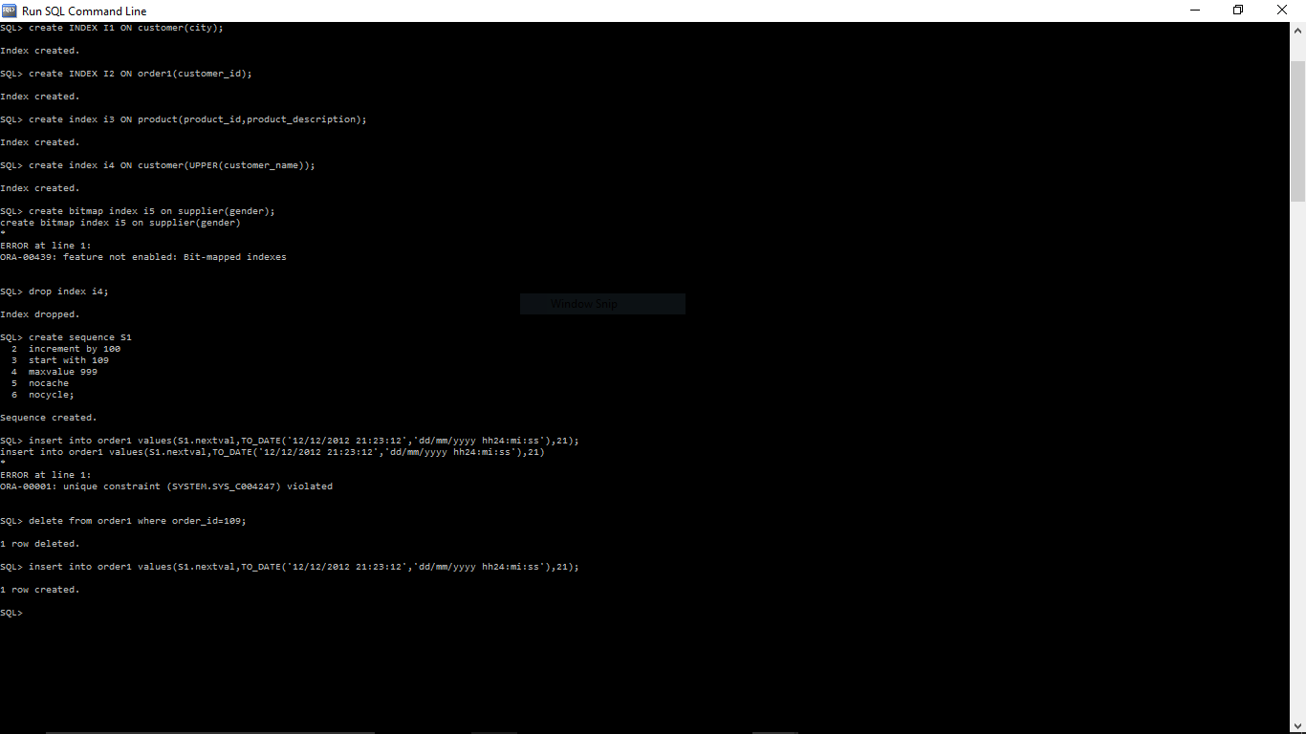

**Result:**

Indexes and sequences were successfully created and tested for all the different situations